Google Maps for Power BI   
Configuration Guide



Contents

**Overview** 3

**Google Maps API Configuration** 3

**Google Maps for Power BI component configuration** 8

# **Overview**

Thank you for installing the Google Maps for Power BI component.

**FEATURES**:

- Switch to Google Street View when needed

- Use Map to filter results

- Share search results and travel routes

- Minimum number of pushpins in a group (i.e. "start grouping when there are more than 3 pushpins by default)

- Fields in a pop-up (when you click on a pushpin)

- Max number of pushpins to show

# **Google Maps API Configuration**

In order to use Google Maps in Power Bi - **Maps JavaScript API** must be enabled. Then Google Maps API Key can be generated.  
  
To do that:

1. Go to https://console.cloud.google.com and scroll to the bottom of the left-side menu

2. Select Google Maps -> APIs  
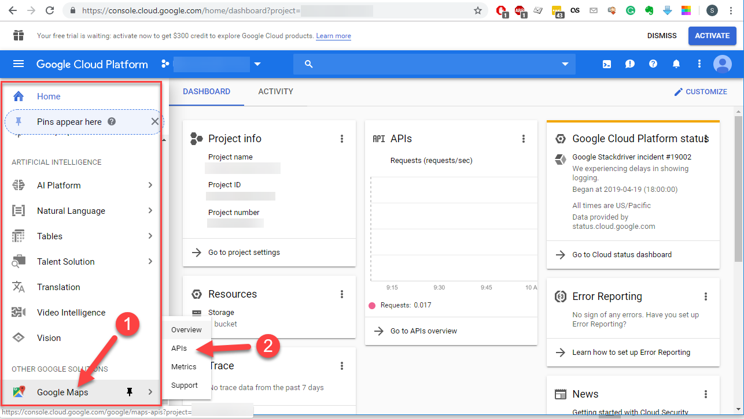  
  
3. Find **Maps JavaScript API**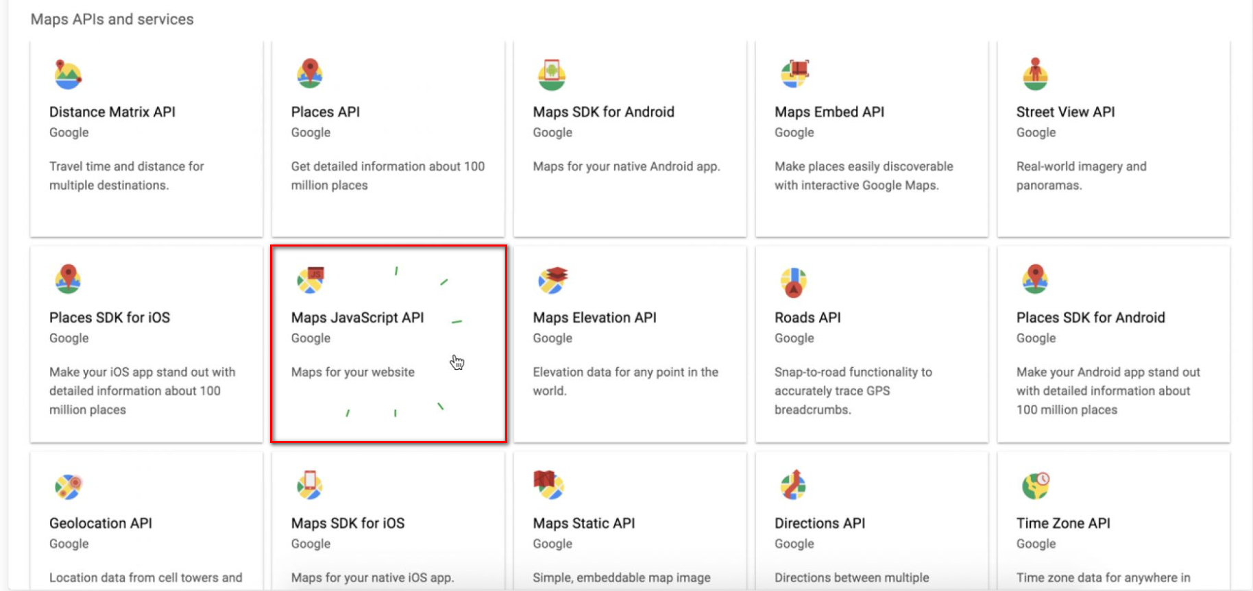

4. Enable **Maps JavaScript API**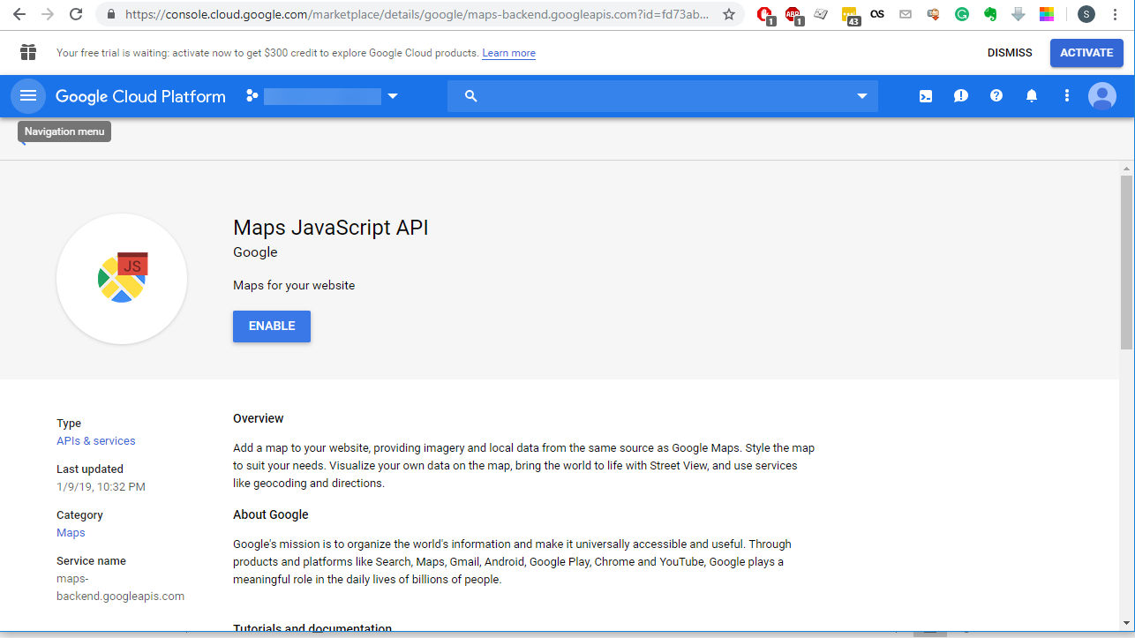

5. Go to **Google Maps** -> **APIs** section again  
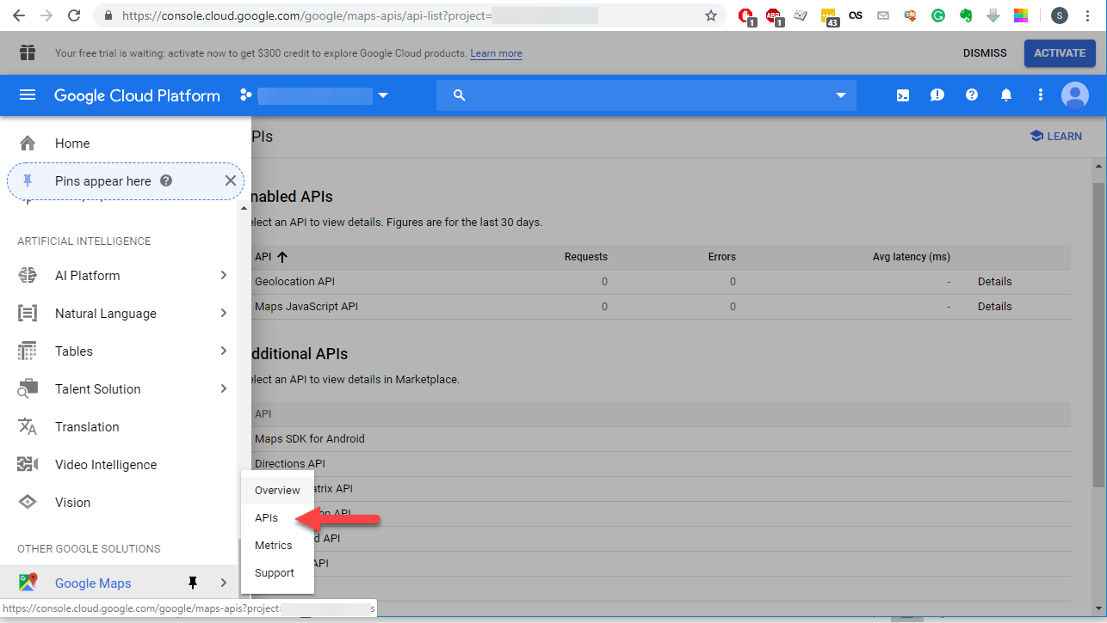  
  
6. Open either **Maps JavaScript API**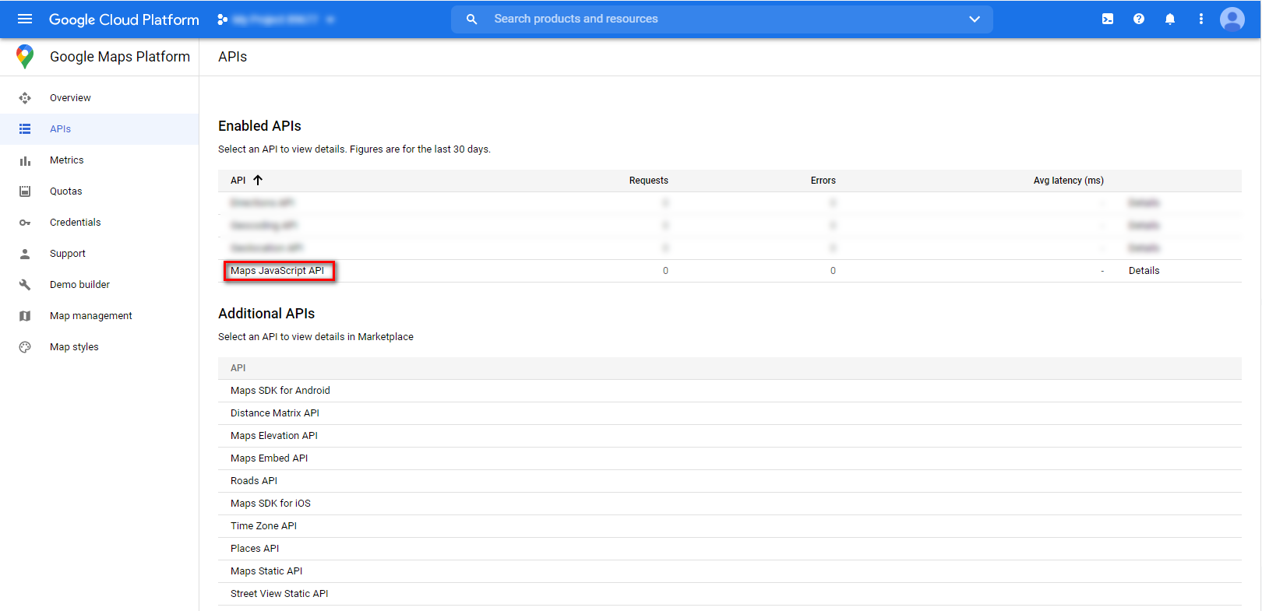

7. Click on **Credentials** to find API key  
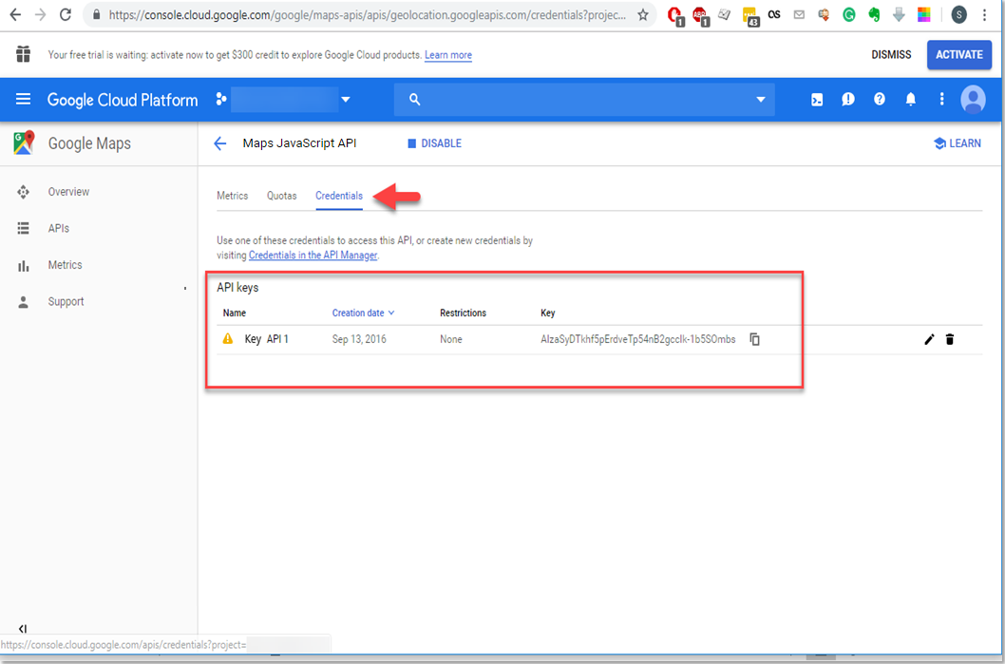  
  
  
8. If **no API keys** to display  
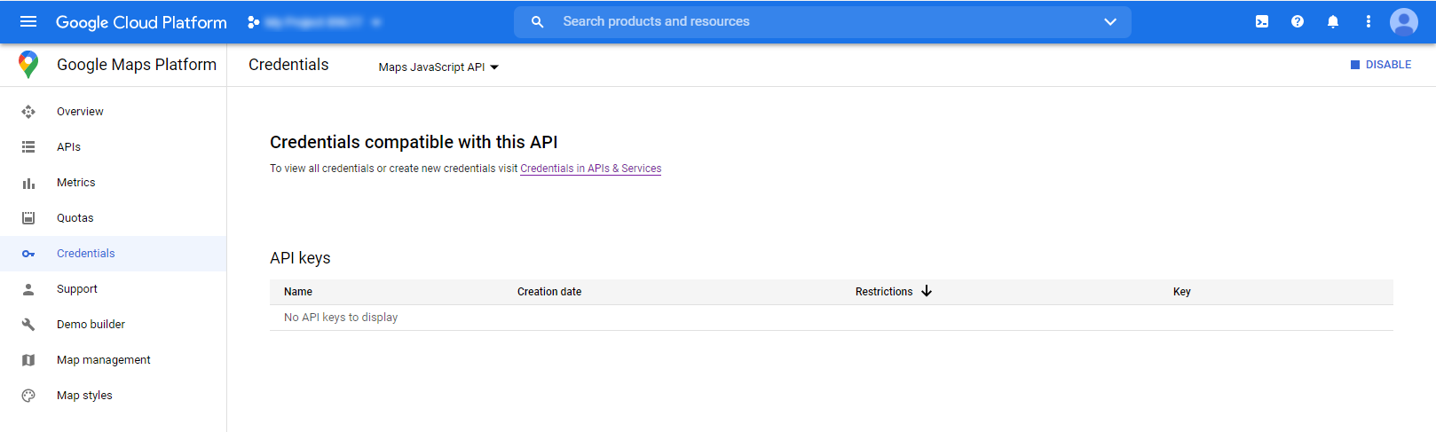

9. Go to the **APIs & Services > Credentials** page  
https://console.cloud.google.com/project/_/apiui/credential  
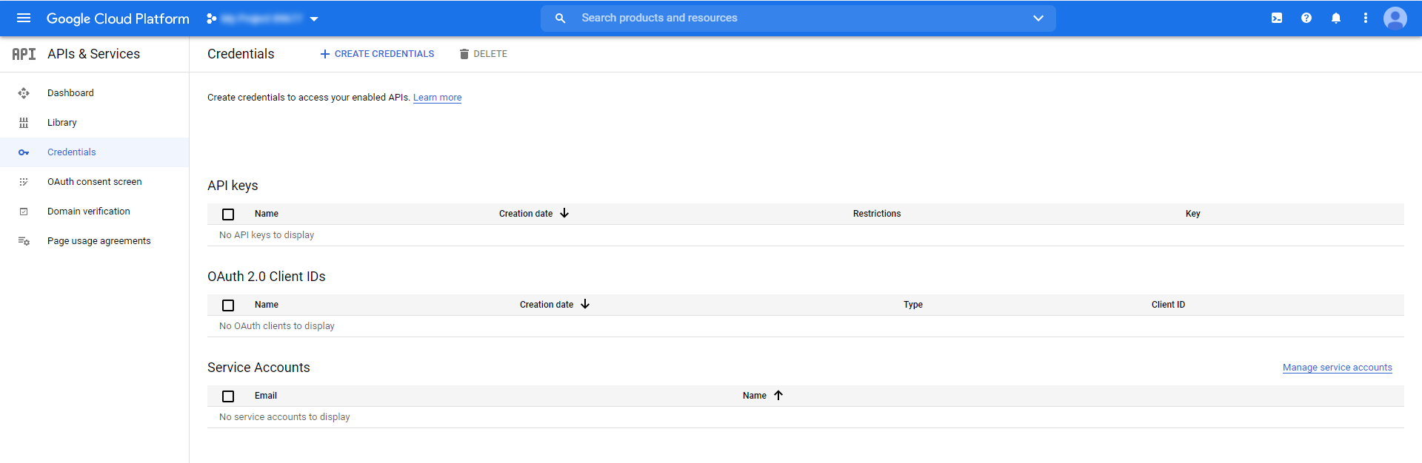

10. On the **Credentials** page, click **Create credentials > API key**. The **API key created** dialog displays your   
newly created API key.  
  
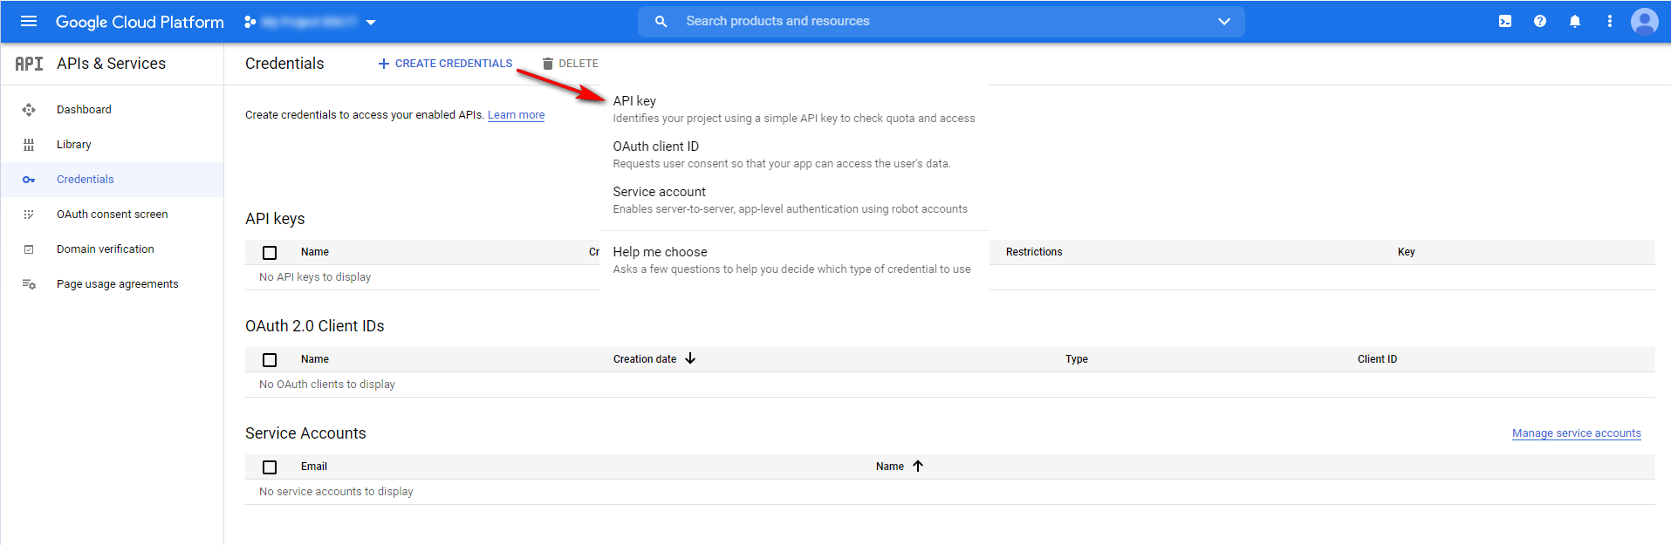

11. Click **Close.** The new API key is listed on the **Credentials** page under **API keys**.(Remember to restrict the API key before using it in production.)

# **Google Maps for Power BI component configuration**

After **Google Maps for Power BI** component installation few simple configuration steps must be done:  
  
1. Import installed Power BI template: **File -> Import -> Power BI visual from file**  
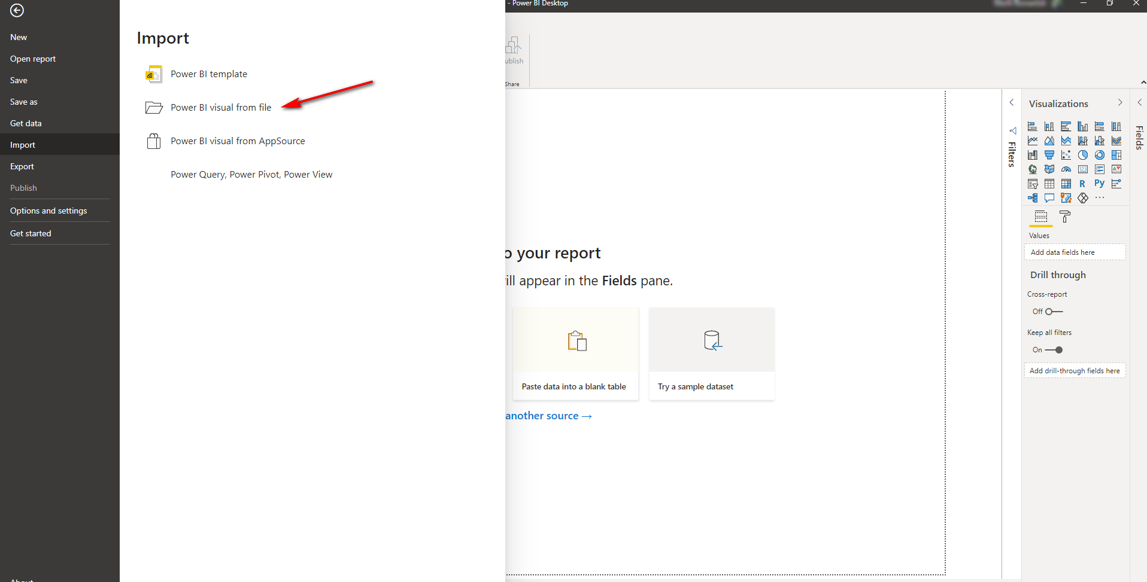  
  
2. Click **Ok** after importing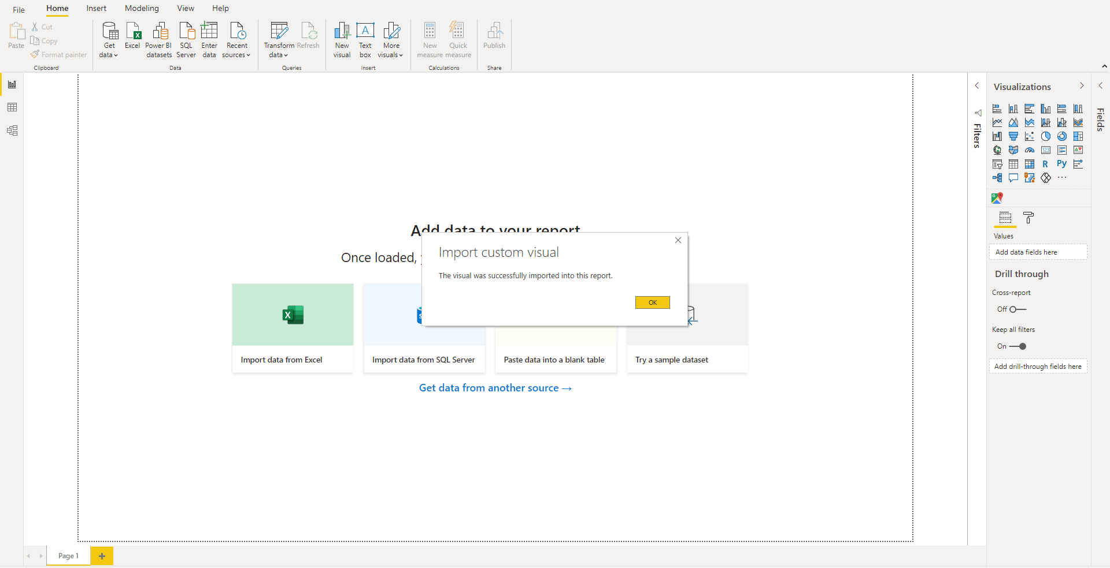

3. Get your **data**  
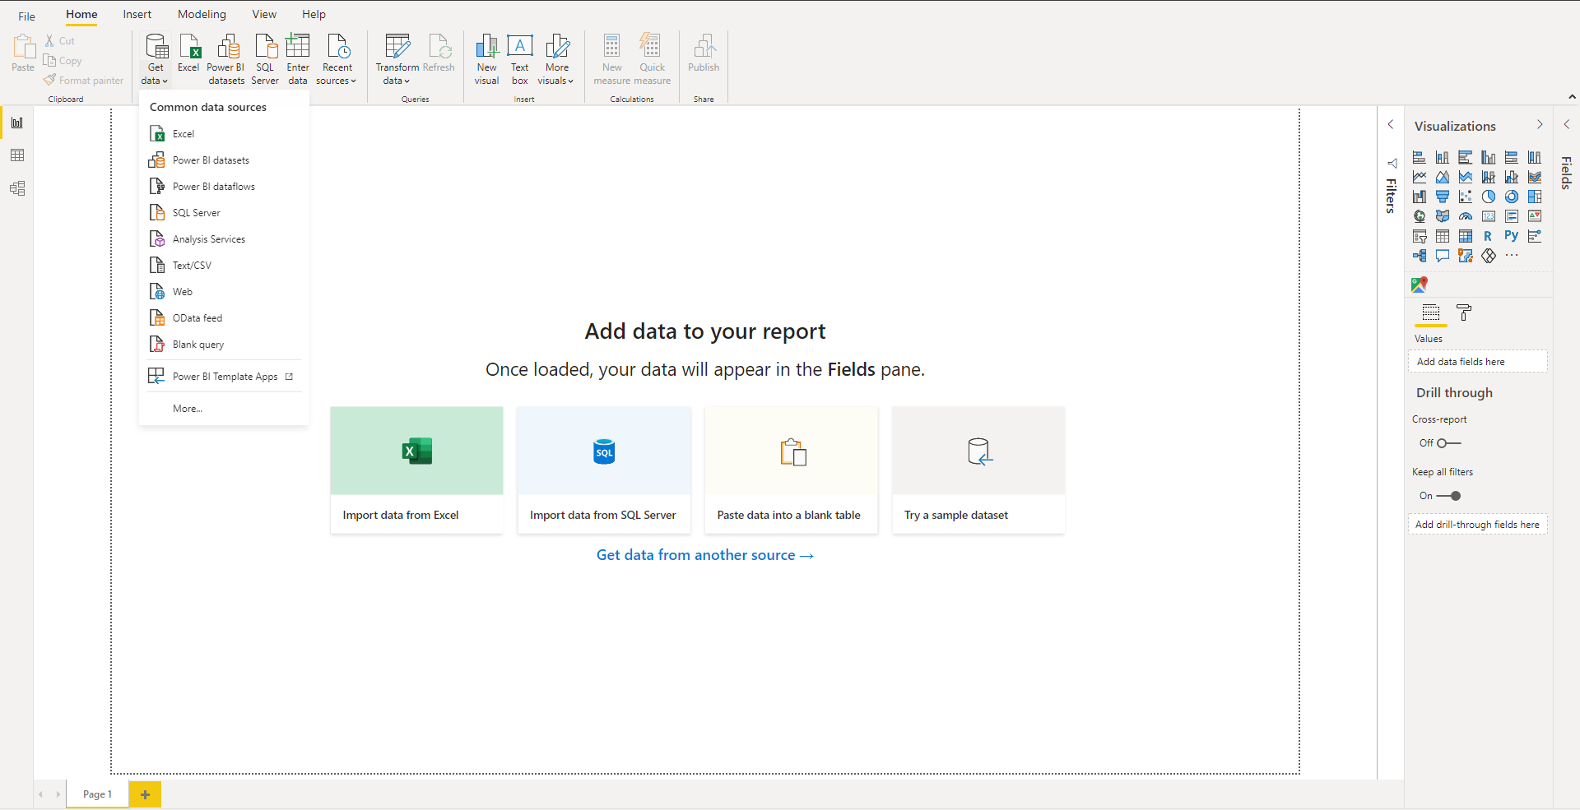

4.Build visuals with your data: Select **Google Maps for Power Bi component**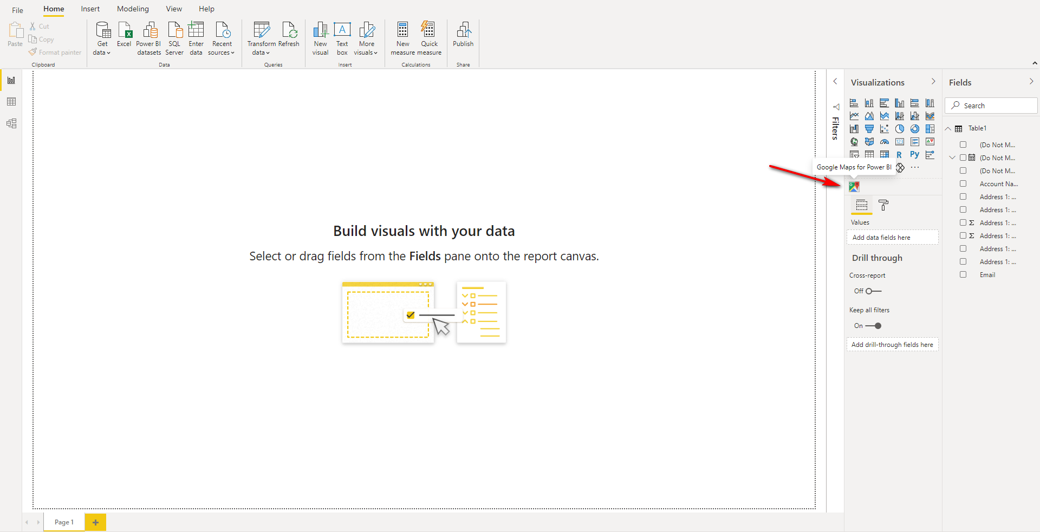  
  
  
  
  
  
  
  
  
  
  
  
  
  
5. Fill the next fields:  
 - **ID**: Unique record ID  
 - **Latitude and** **Longitude**: Are the units that represent the coordinates at the geographic coordinate   
 system  
 - **Tooltips**: Select one or more columns from the table to display on the map   
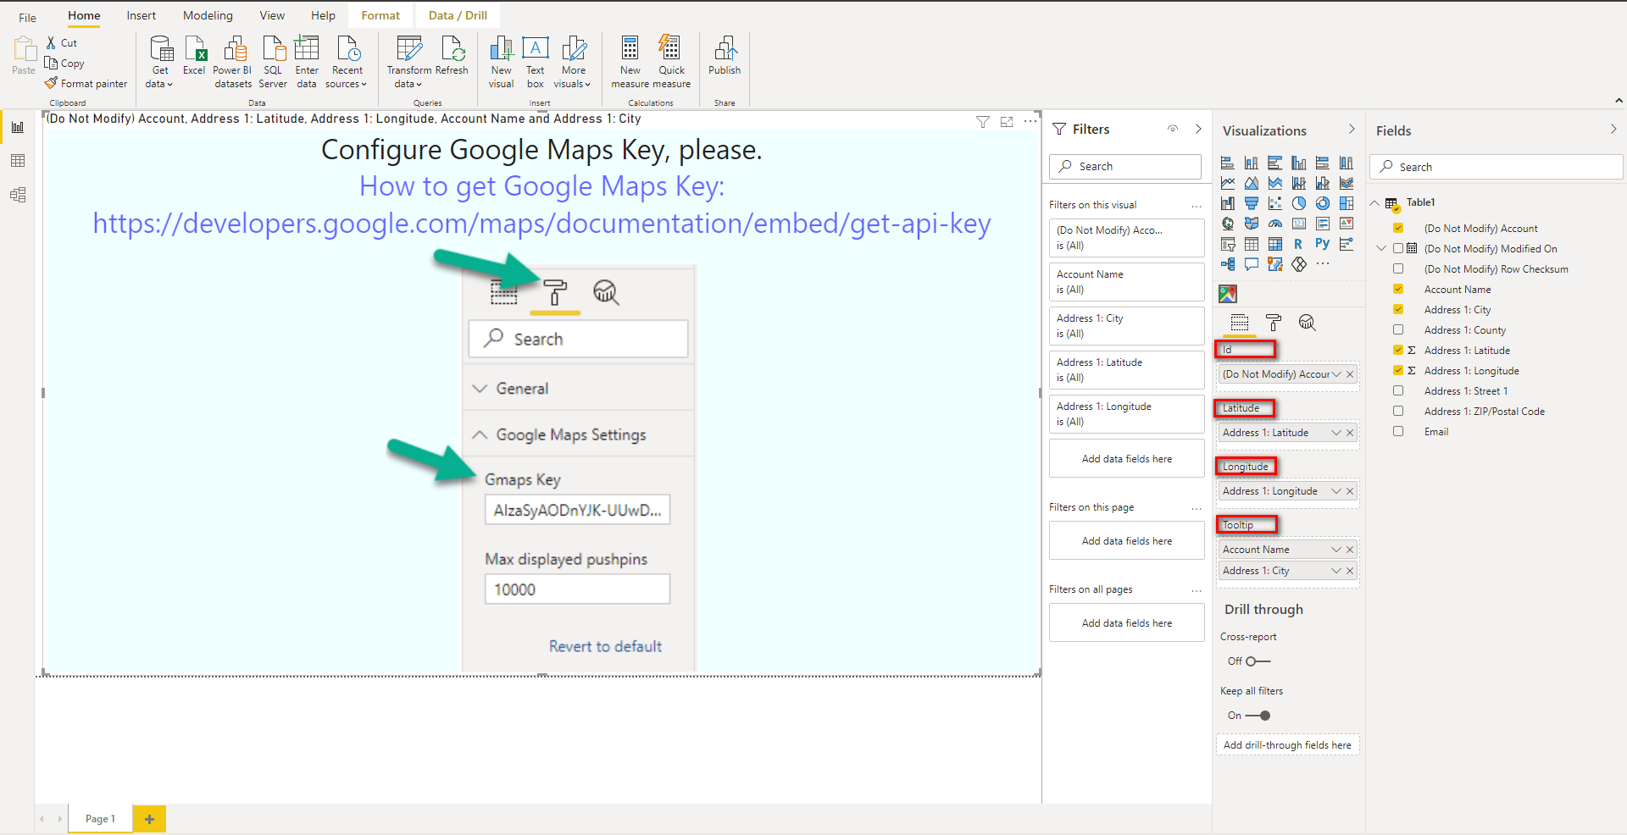

6. Fill **Google Maps Settings**  
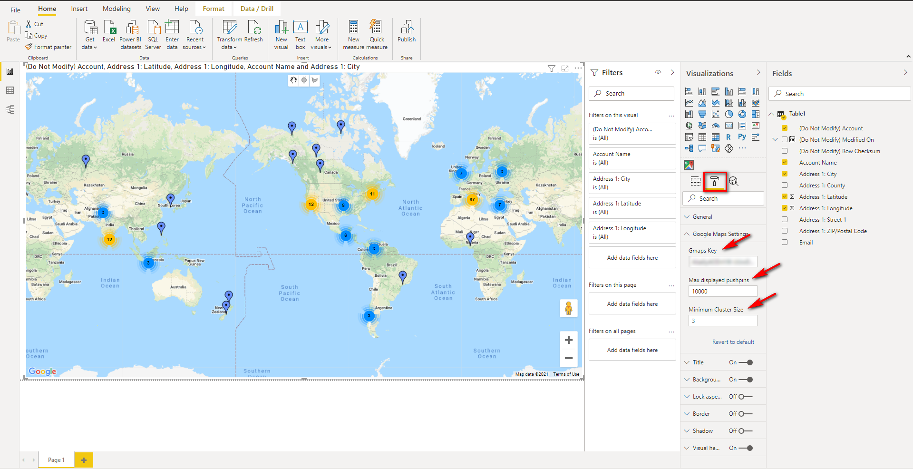7. **Save** the current report